Change history for Copy Paste Tool

Version: 2024.11.06

Maciej Szymczak

Table of contents

Release 2022.03.25 1

Release 2019.07.29 2

Release 2019.01.01 2

Release 2018.07.19 3

Release 2018.07 3

Available in Lightening 3

Progress Bar 4

Improved sorting 5

Release 2018.03 6

External Fields: bugfix 6

SOQL Statistics 6

Copy Paste Tool is now integrated with SQOL Explorer 7

Permission Sets 8

# Release 2022.03.25

Support for UK regional settings: Dates and Formats

Better colors.

Api 54.0.

# Release 2019.07.29

Action on success/ failure, improved permission sets and page layouts

# Release 2019.01.01

Action of success/ failure, improved permission sets and page layouts

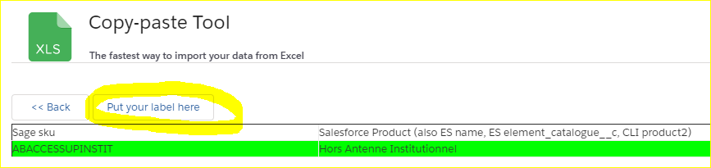

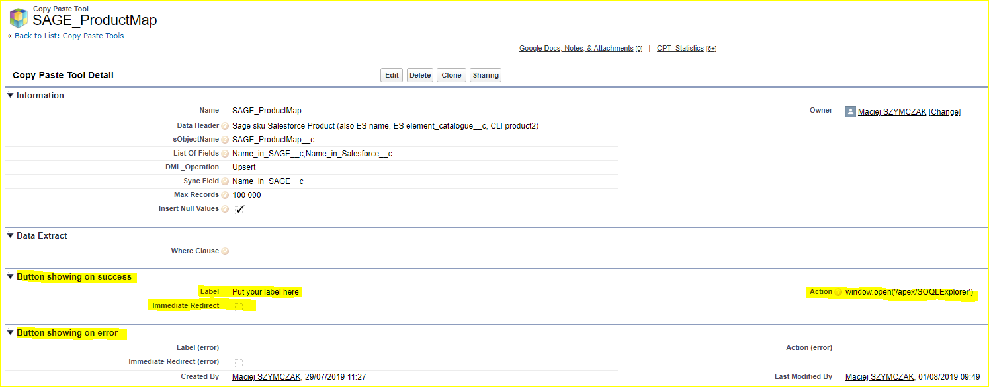

# Release 2018.07.19

Disabled Track Activities

# Release 2018.07

## Available in Lightening

Copy Paste Tool is now available in Lightening.

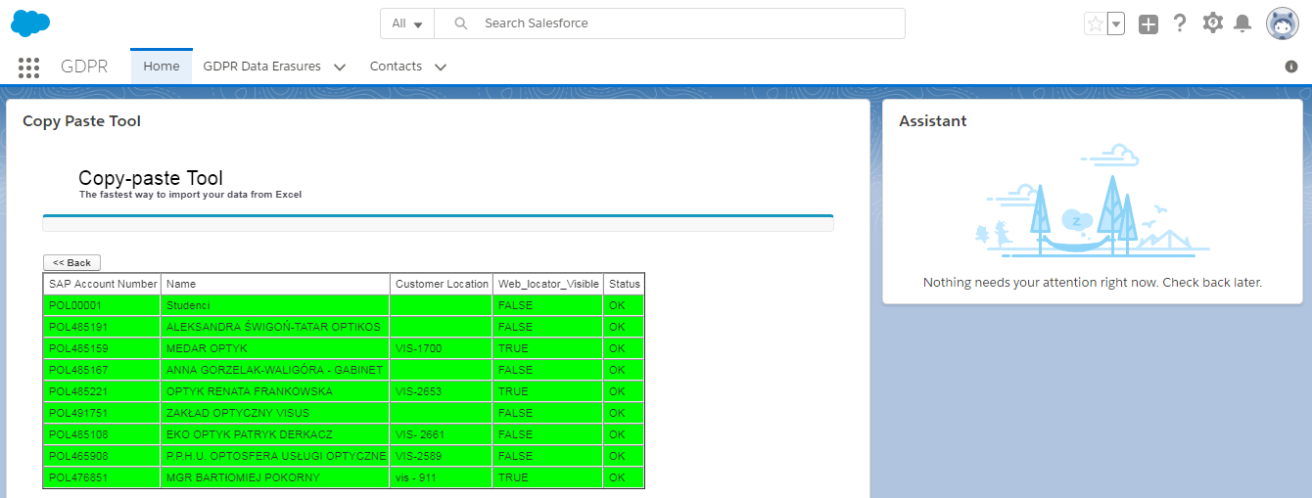

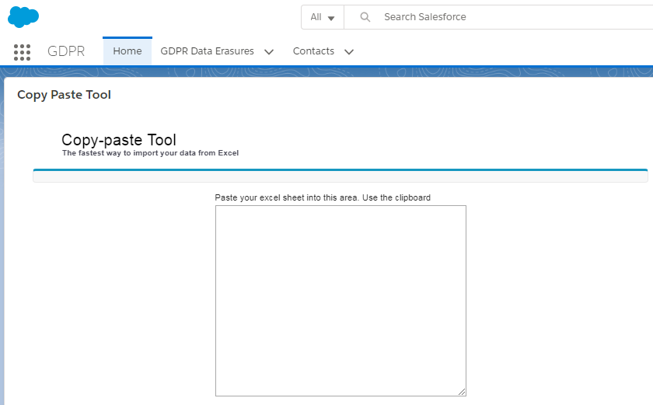

## Progress Bar

Copy Paste Tool can be used to upload thousands od records.

Former version however displayed message “Page nonresponsive”.

Current version displays Progress Bar informing the user about approximate finishing time.

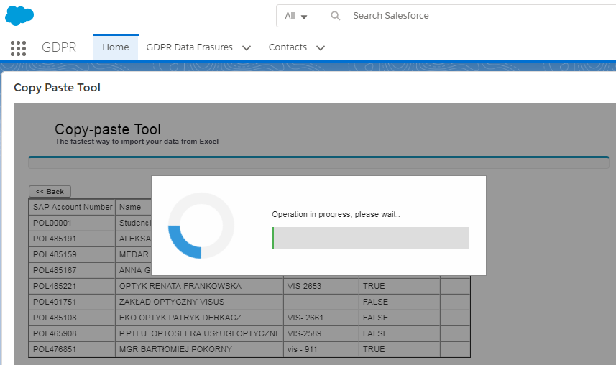

## Improved sorting

Configuration table now is displayed in alphabetic order.

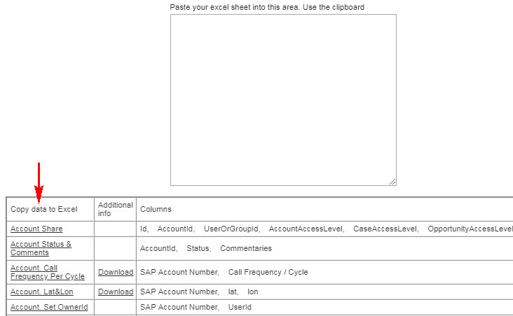

# Release 2018.03

## External Fields: bugfix

External fields work properly unless one tried to set the value NULL. The value NULL caused an error.

This has been rectified. Now NULL values are supported too.

## SOQL Statistics

*Copy Paste Tool* keeps the statistics on the number of changed rows along with date time and the user name.

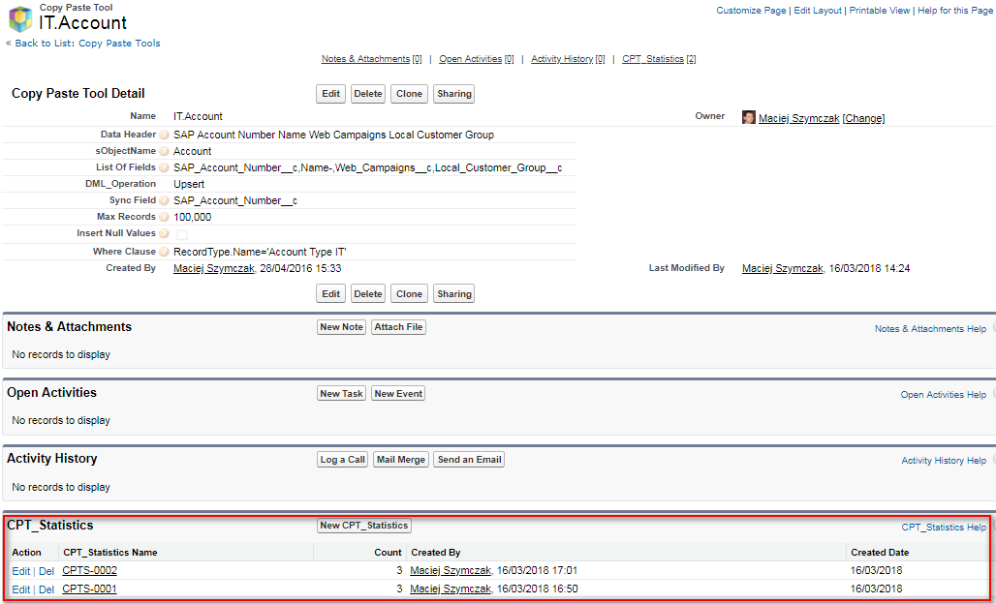

## Copy Paste Tool is now integrated with SQOL Explorer

SOQL Explorer is the tool for admins that gives instant, robust and very convenient access to Salesforce Schema and SOQL.

How to Run SOQL Explorer:

There is a new button *SOQL Explorer* on the bottom of the page: 

A quick introduction to SOQL Explorer:

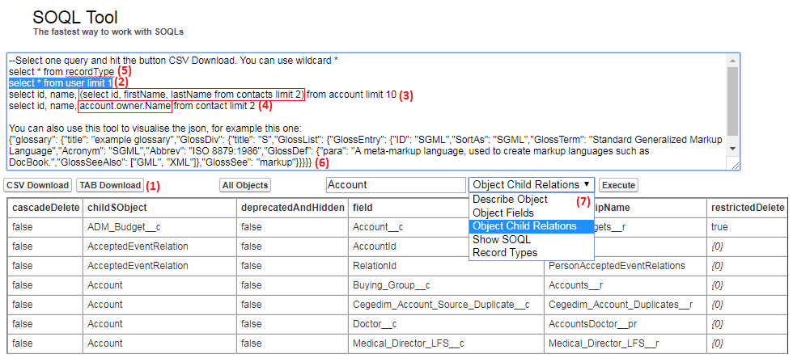

1. Rapid download SOQL results to Excel / CSV file
2. You can work with many SOQLs, just select the active one and hit Download
3. Nested queries are supported
4. Nested lookup are supported too
5. The syntax like “select * from” is supported (!)
6. You can use this too to visualize jsons
7. Convenient access to metadata:
   1. List of all Salesforce Objects
   2. List of all details of selected object
   3. List of object fields
   4. List of object child relations
   5. Complete SQLs for given object (select * from)
   6. Record types for given object

## Permission Sets

Two permission sets were added to the solution:

|  |  |
| --- | --- |
| Permission Set Name | Description |
| Copy Paste Tool User | Gives the access to regular user |
| Copy Paste Tool Admin | Gives the admin access.  Admin can modify Configurations, External Tools as well execute SOQL Explorer. |

Obsolete Permission Set: ~~Copy Paste Tool~~